**ROLL NO: 2024510001 BATCH: A**

**NAME: ATHARVA VASANT ANGRE**

**EXPERIMENT NO: 06**

**EXPERIMENT TITLE: Create Work breakdown Structure and Plan Gantt Chart**

**Objective:**

1. **To Establish the Project Start or Finish Date.**
2. **To analyze Task and sub task for give task.**
3. **To add task and sub task durations.**
4. **To add Resources and allocate the task.**
5. **To develop Gantt chart for given case Study.**
6. **To develop pert/CPM chart for given case study.**

**STEP 1 :** First ADD the task and Sub task and set duration of each click ok.

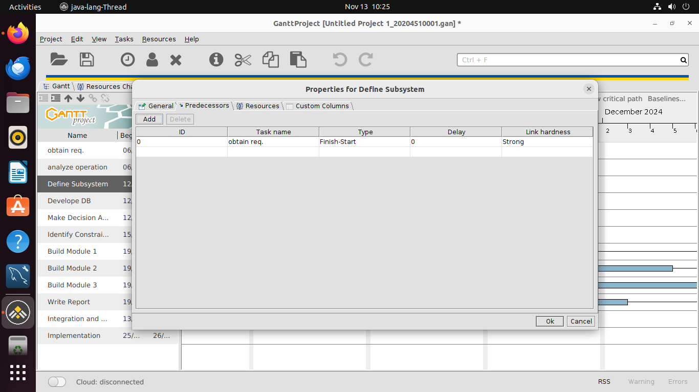

STEP 2: Assign resources to each of the task

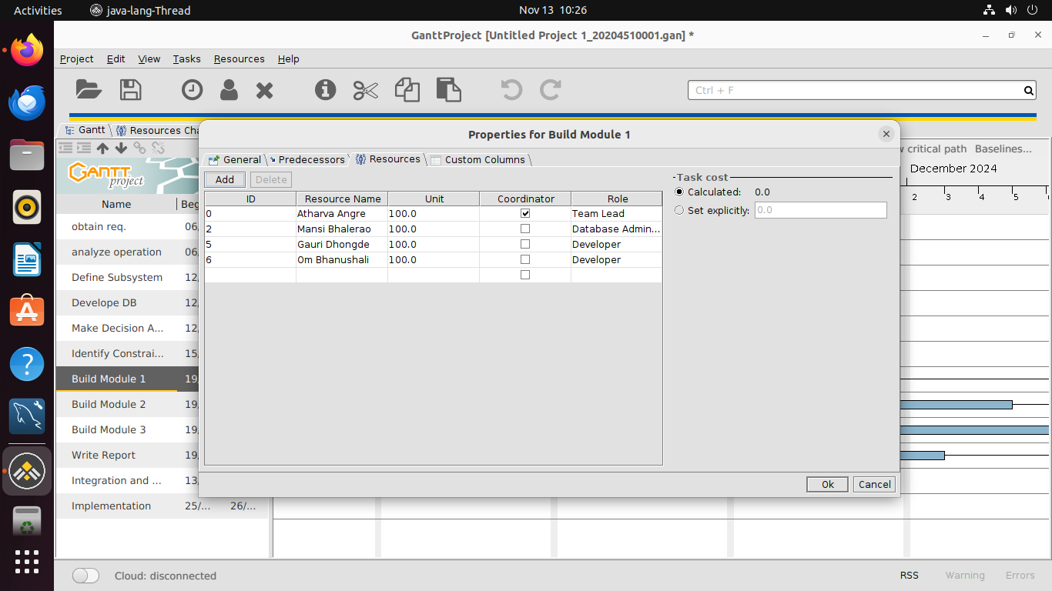

**STEP 3:** This is the Gantt Chart.

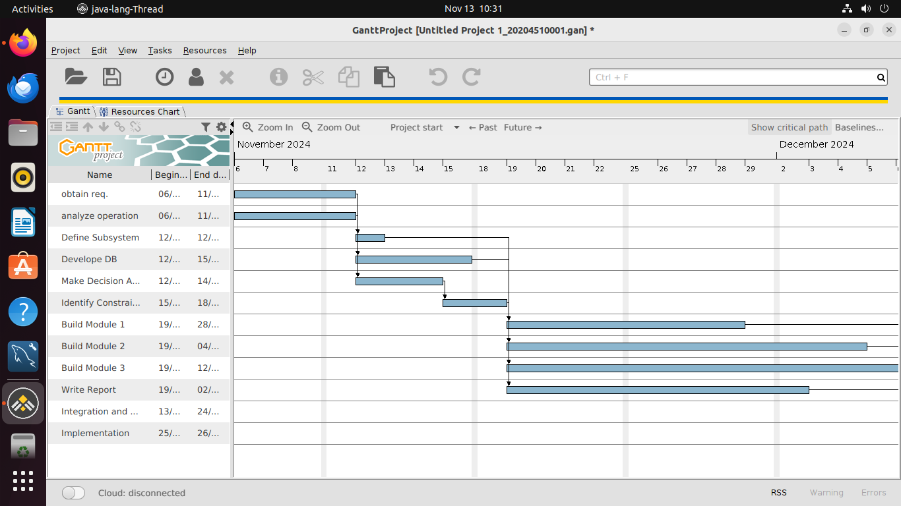

**STEP 4 :** This is the Resource chart.

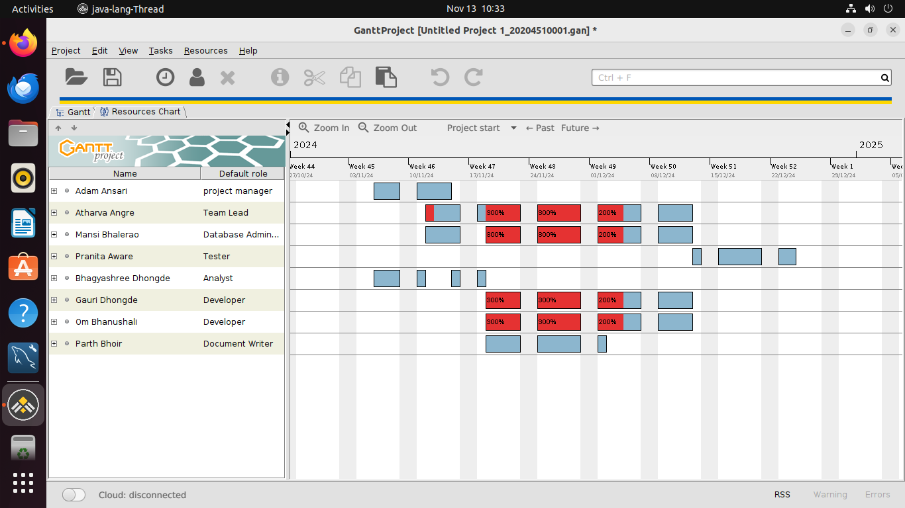

**STEP 3:** This is the Pert chart.

